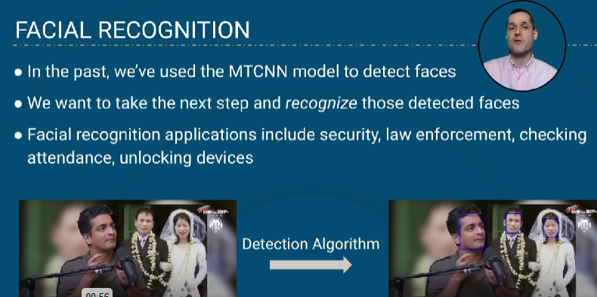

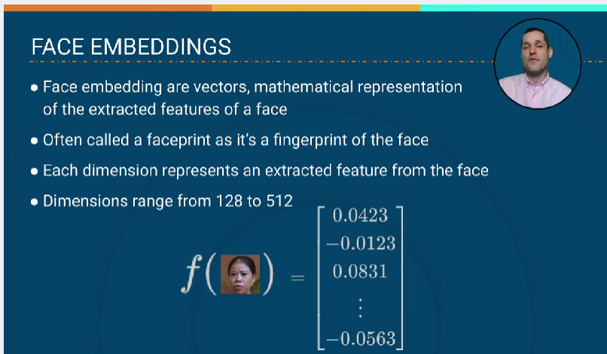

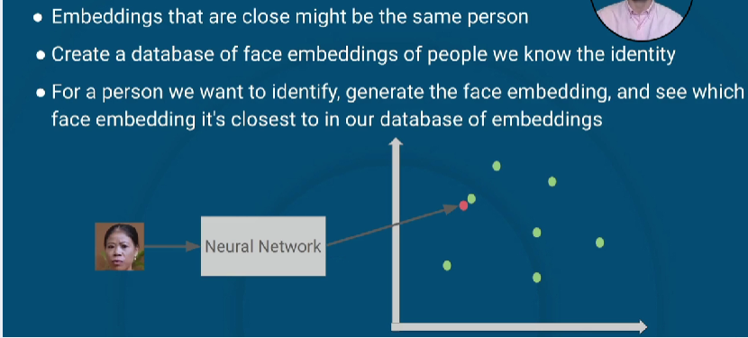

**MODEL USED TO GET FACE EMBEDING**

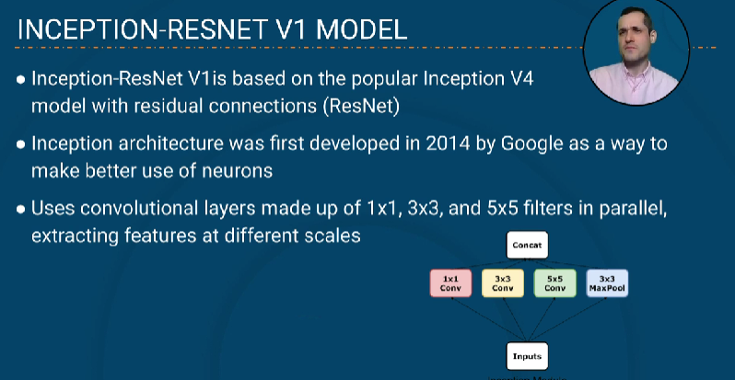

Residual connections are also used in each inception module, inception-ResNet v1 has inception modules , and that inception modules has residual connection.

**What is residual connection?**

It is a block that clones the input and skips some of the functions, in below example x is the input, so f(x) is the residual block, because of this connection it trains model more faster.

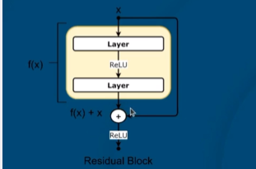

The module used for face detection has the Inception-ResNet V1 model to do face embedding.

